Allergen Matrix Example
(Note – Please state the name of the cereal(s) containing gluten* and/or the name of the nut(s)†)

Dishes | 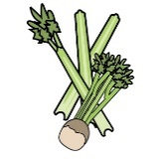 | 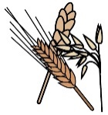 | 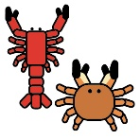 |  |  | 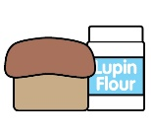 |  |  | 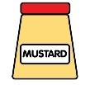 | 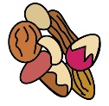 | 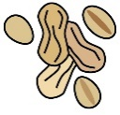 | 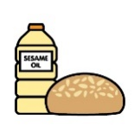 |  | 
 | Celery | Cereals containing gluten* | Crustaceans | Eggs | Fish | Lupin | Milk | Mollusc | Mustard | Nuts† | Peanuts | Sesame seeds | Soya | Sulphur Dioxide
HOT DOG WITH ONIONS | ✓ | ✓ |  |  |  | ✓ | ✓ |  |  |  |  |  | ✓
PULLED PORK SANDWICH | ✓ | ✓ |  |  |  | ✓ | ✓ |  | ✓ |  |  | ✓ | ✓
PIE AND PEAS | ✓ | ✓ |  |  |  | ✓ | ✓ |  | ✓ |  |  |  | ✓
SAUSAGE ROLL | ✓ | ✓ |  |  |  | ✓ |  |  | ✓ |  |  |  | ✓
VEGAN PIE |  | ✓ |  |  |  | ✓ |  |  |  |  |  |  | ✓
BUTTERNUT SQUASH PIE |  | ✓ |  | ✓ |  | ✓ | ✓ |  |  |  |  |  | ✓
CHRISTMAS PASTY |  | ✓ |  |  |  | ✓ | ✓ |  | ✓ |  |  |  | ✓

Review date: | 30/01/2025 | Reviewed by: | (CATERING MANAGER) |  |  |  | You can find this template, including more information at www.food.gov.uk/allergy-guidance

